**CA400 Final Year Project**

**User manual**

**DCU Campus Chatbot**

**Sam Wood - 16476066**

**Mark Agnew - 16315811**

**Project Supervisor: Gareth Jones**

**Table of Contents**

**1. Introduction** **3**

**2. Installation guide** **3**

2.1 Pulling the files 3

2.2 Setting up the environment 3

2.3 Installing the packages 3

2.4 Running the Program 4

**3. User guide** **4**

3.1 Decipher Campus Building Codes 5

3.2 Building Directions 6

3.3 Lecture room directions 7

3.4 Campus Building images 7

3.5 Food store/ shop directions 8

3.6 Help 8

3.7 Options menu 10

3.8 Spelling Correction 11

3.9 Bus Information 11

**4. Appendix of commands** **12**

4.1 Building codes 12

4.2 Building directions 12

4.3 Room directions 12

4.4 Building images 13

4.5 Frequently asked questions 13

4.6 Help commands 13

# 

# 1. Introduction

This is the user manual for the DCU Campus chatbot. This document has been created to cater for first time users of the product. There are no restrictions as to who may and may not read the following as all app users will have access to the documented features that the project investigators have provided. This document goes through all the necessary steps to install the application locally and gives information on the key features of the application, along with various images of the application in use. Our system aims to help those new to DCU campus by allowing them to ask questions to our chatbot to find out information. This includes information about where certain rooms across campus are, what some of the buildings[1] around campus look like, interpreting room/building codes from class timetables and answering some FAQs about campus. We will also highlight the commands that can be used to retrieve this information in this manual.

# 2. Installation guide

The main idea behind our project is not that it would be installed on every user's device but a university or business server. However there are requirements in order to allow the program to run as it uses a few python libraries.

## **2.1 Pulling the files**

To first install the application you need to pull the files from the projects gitlab repository found here : <https://gitlab.computing.dcu.ie/agnewm4/2020-ca400-agnewm4-woods2>

## **2.2 Setting up the environment**

Next open up the folder from the downloaded zip as a project in a suitable IDE for handling python, html and javascript files (We used PyCharm, but any one you are comfortable installing python packages on and running python files in will do fine).

## **2.3 Installing the packages**

Below are the links to the necessary python packages that need to be installed and the pip command to install them.

-Autocorrect:

Link - <https://github.com/fsondej/autocorrect>

Command - pip install autocorrect

-Python-aiml:

Link - <https://github.com/paulovn/python-aiml>

Command -pip install python-aiml

-FuzzyWuzzy (word comparison):

Link - <https://github.com/seatgeek/fuzzywuzzy>

Command - pip install fuzzywuzzy

Optional:

-Python-Levenshtein (speeds up FuzzyWuzzy):

Link - <https://github.com/ztane/python-Levenshtein/>

Command - pip install python-Levenshtein

In order to get this package to install properly I also needed Build Tools for Visual Studio 2019 found here :

<https://visualstudio.microsoft.com/downloads/#build-tools-for-visual-studio-2019>

I from that you need to install the following 4 items:

1. Visual C++ Build tools core features.
2. VC++ 2017 v141 toolset (x86,x64)
3. Visual C++ 2017 Redistributable Update
4. Windows 10 SDK (10.0.16299.0) for Desktop C++

This may not be the case for everyone but did solve an error relating to “fatal error C1083: Cannot open include file: 'io.h': No such file or directory” That I received while trying to pip install this package.

## 2.4 Running the Program

Lastly when all the packages are installed correctly run the Chat.py file and the website will start running on the localhost at port 5000.

# 3. User guide

When the application is started the user is brought to the home screen of the website. There is a general set of instructions at the bottom of the page which talks about the help and contact pages of the application. To begin the chat with the application, the user need only select the ‘Start Chat now’ button.

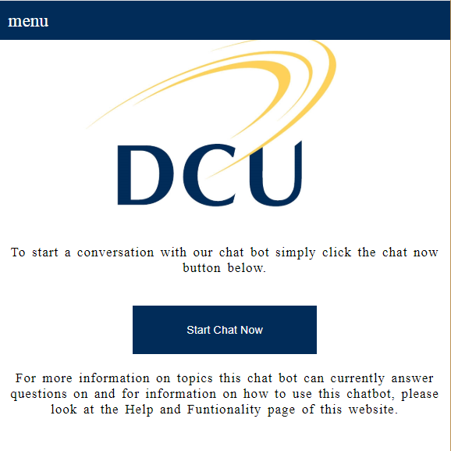

The menu button in the top left corner of the app is what the user will use to move between pages. The above image is taken from when the app is used from a desktop. We have also made the app usable from a smartphone i.e. Android or iPhone, in which case the image is resized but still very similar.

## 3.1 Decipher Campus Building Codes

To acquire the meaning of any of these codes, the user can text the code itself, or simply ask what it means.

..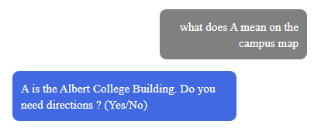

*Fig 3.1*

The meaning of the code is then sent to the user and they then have the option to get directions from the Campuses closest entrance (Ballymun or Collins avenue).

## 

## 3.2 Building Directions

Following the last feature, should the user reply ‘Yes’ to the bot, the user will be given directions to the Albert College Building. Outside of this, the app user can message the name of whatever building it is or ask as they normally would to another human.

.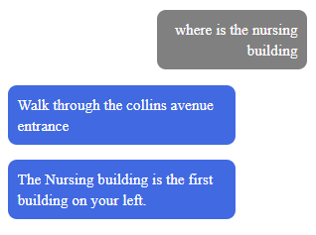

*Fig 3.2*

To make things even simpler the user can message the name of the building alone for the same response.

The two entrances are highlighted with red arrows on the campus map below.

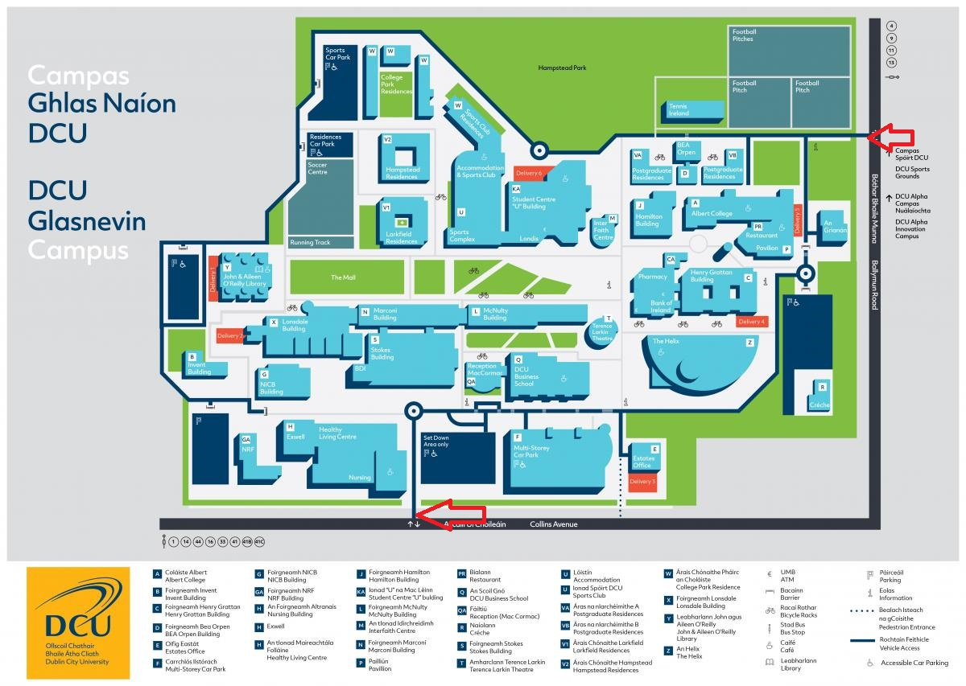

*Fig 3.3 See red arrows for the location of the Ballymun and Collins ave entrances.*

## 3.3 Lecture room directions

This feature is much like the building directions. The user can text the code for the rooms allocated for lectures and labs in the Business, Nursing and Computing building.

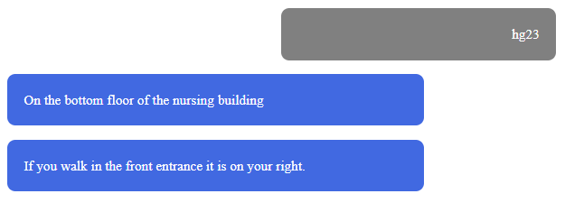

*Fig 3.3*

The user is then given a description of where the room is in relation to the building it is in, Usually the bottom floor. The User can also ask what the code means like it would to another person i.e. ‘Where is HG23’, and the answer will be provided.

## 3.4 Campus Building images

Should the user not find the directions to the buildings particularly helpful, they can also be sent images of the various buildings by sending the name of the building followed by the word ‘Image’.

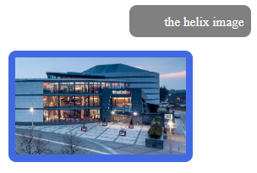

*Fig 3.4*

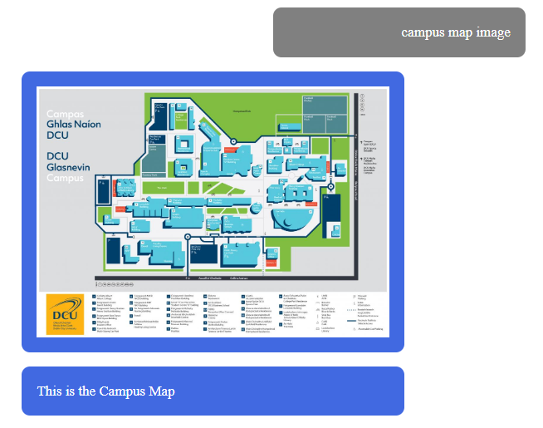

*Fig 3.5*

After this feature was implemented, there were now 3 means of helping the user find their way around campus including the building codes and the building images. Also, a list of some of the building images can be retrieved with the query ‘building image list’.

## 3.5 Food store/ shop directions

The user can also acquire directions to the various food stores on the Glasnevin campus. The help function tells the user about the ‘SHOP LIST’ query that can be sent which will return the list of food places on the DCU campus. The directions to these areas can be acquired the exact same way the building directions are.

## 3.6 Help

The user can text the ‘Help’ function and a series of commands are provided that give more information about the functions in the application that are mentioned above.

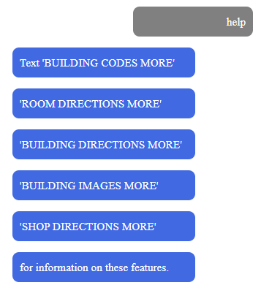

*Fig 3.6*

These commands will provide the user with a brief message of what the function does and also an example of a conversation with a user using this feature.

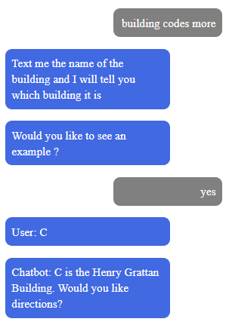

*Fig 3.7*

If the user responds ‘Yes’ to this they can get directions to the Henry Grattan. Just like in the image above, examples can also be given to the user for building directions and lecture rooms.

## 3.7 Options menu

The options for the chat interface is represented by a generic settings symbol. The option menu appears coming from the left hand side of the screen and produces a similar layout to the main menu.

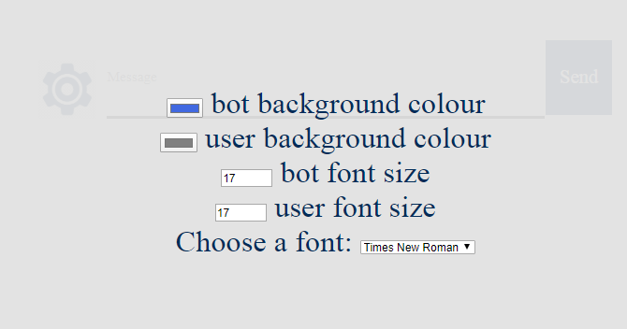

*Fig 3.8*

The two different chat box colours can be changed to various different colours.The two chat box font sizes can also be altered if the user feels the writing is too difficult to read. Finally the user has the option to change the font style to one of 4 options.

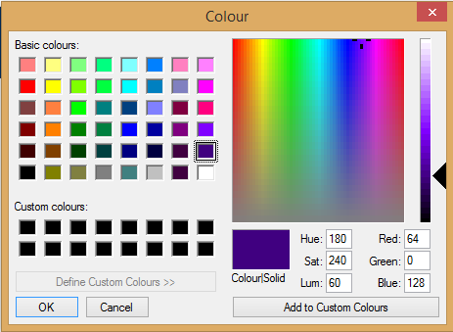

*Fig 3.9 Above is what the user uses to change the colour of the message boxes*

## 

## 

## 

## 3.8 Spelling Correction

This application also corrects any possibly misspelled words once a message is entered, this is to ensure the bot is able to return the best response possible answer. This is done in the background but means you should get the most accurate answer from our application. Below is an example of this.

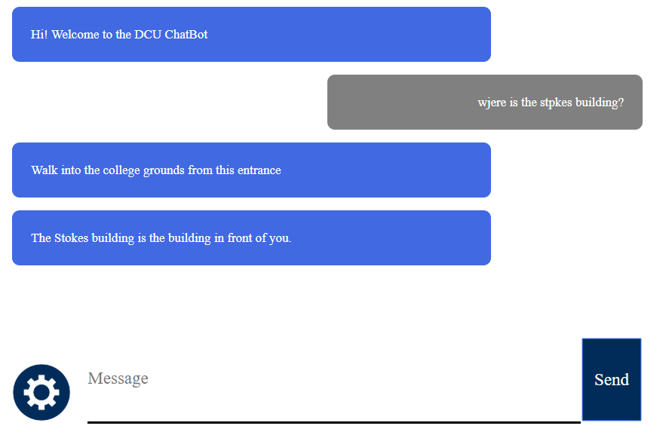

*Fig 3.10*

## 3.9 Bus Information

Another feature we felt was necessary to add was information regarding the buses that students would use when commuting. You will be given the option to see a list of all the busses and their route.

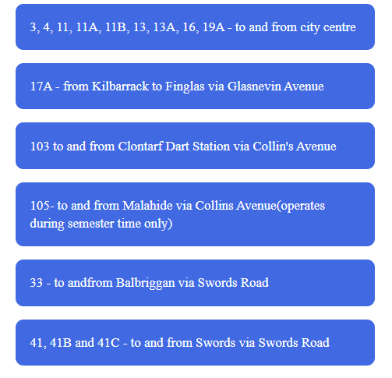

*Fig 3.11*

Above is a snippet of some of the busses that are retrieved. The user can also get this list by typing ‘bus list’.

# 4. Appendix of commands

## 4.1 Building codes

“Tell me what A is” is a sample command for this feature and will work when phrased to the users liking. A, B , C, D, E, F, G, GA, H, J , KA, L, M, N, P, PR, Q, R, S, T, U, VA, VB, V1, V2 are all of the building codes.

## 4.2 Building directions

Directions can be provided to the Library, Albert College Building, Invent Building, Henry Grattan, BEA Orpen Building, estates office, multi-storey Carpark, NICB Building, Nursing Building, Hamilton Building, Students U building, Computing Building, Interfaith centre, Marconi Building, Pavillion, Canteen, Business Building, the Creche, Engineering Building, Terrence Larkin Theatre, Sports Complex, Helix, Postgraduate residences, Larkfield residences and Hampstead residences. The question can be phrased to the users liking.

Directions to various shops and food stores like Londis, Helix cafe, Nubar and the canteens in the Nursing, Business and Library canteen.

## 

## 4.3 Room directions

Nursing building: HG05, HG06, HG07, HG08, HG09, HG10, HG11, HG12, HG13, HG50, HG20, HG22, HG23, HG19, HG18, HG17, H136, H137, H138, H139, H124, H125,

Business building: QG01, QG02, QG03, QG04, QG06, QG13, QG15, QG21, QG22, QG24, QG27, QG28, QG30, Q119, Q120, Q121, Q122, Q157, Q158, Q217, Q219, Q220, Q218, Q205, Q202, Q301, Q302, Q303, Q304, Q305 and Q306.

Computing building: LG25, LG26, L114, L101, L125, L128 and L129.

## 4.4 Building images

NICB building, Nursing building, Albert college building, BEA orpen building, Business building, Canteen, Carpark, Computing building, Engineering building, Helix, Henry Grattan, Invent building, Postgraduate residences, Science building and the terrence larkin theatre.

The user can also get an image of the campus map upon request.

## 4.5 Frequently asked questions

“Where is Registry ?”, “Where can I get a student card ?”, “Where can I get a timetable ?”, “When is graduation ?”, “How do I change my modules ?”.

## 4.6 Help commands

“Help”, “Building Images More”, “Room directions more”, “Building Directions More”, “Building Codes More”, “Shop Directions More”, “Building Image List”, “Shops List”, “Computing Building rooms”, “Nursing Building rooms”, “Business Building Rooms”.

1. Due to restrictions imposed by Covid-19 we only have a small sample of building images and room directions.